UNIT V
iOS
IOS stands for iphone operating system. It is a proprietary mobile operating system of apple for its handheld. iOS is a mobile operating system developed by Apple. iOS is used to implement applications for Apple products such as iPhone, iPad, Apple TV, etc.. It supports Objective-C, C++, Swift programming language. It is based on the Macintosh OS X. iPhone, ipod and iPad all comes with IOS.

Overview of iOS
On March 6, 2008, Apple has released the first software development kit (iPhone SDK) without having any official name but after releasing the first iPhone, the OS has named it as iPhone OS. After that, apple has introduced new devices called iPad and iPod on June 7, 2010, based on iPhone OS and the OS name has renamed it as iOS to make it consistent for all the devices.

History of iOS
The following are the details related to the evolution of iOS software.

- In June 2007, Apple has released the first version which is 1.5 and shortly becomes 2.0.
- On July 11, 2008, Apple has released the third iPhone OS 2.0 version.
- July 17, 2009, Apple has released the third iPhone OS 3.0 version.
- June 21, 2010, iOS 4 was released and Apple has provided 1500 new API features including the multitasking feature.
- On June 6, 2011, Apple has released iOS 5 and included iMessage chat between two devices which fully integrate with iCloud features.
- On June 11, 2012, Apple has released iOS 6 version but this version is not accessible for public use. On September 19, 2012 iOS 6 was released in public.
- On June 10, 2013, Apple announced iOS 7 and the features of iOS 7 are only for two iPhones iPhone 5c and iPhone 5c.
- On June 2, 2014, Apple released iOS 8 for iPhone 6 and iPhone 6 plus. iOS 8 is the first version that is available for public beta testing.
- On June 8, 2015, Apple announced the iOS 9 version and it provided support to upgrade from iOS 8 to iOS 9.
- Apple announced iOS 10 on June 13, 2016.
- Apple announced iOS 11 on June 5, 2017,
- Apple announced iOS 12 on June 4, 2018
- Apple announced iOS 13 on June 3, 2019,
- Apple announced iOS 14 on June 22, 2020

Features of iOS
The following are the common features available with apple iOS software.
- Battery problem is a common issue in all iPhone devices. Now, the settings of the iPhone offer to check which application is taking too much battery and we can uninstall or deactivate the applications based on our requirements.
- The feature in iOS is predictive typing which means when we type a word in iOS, it suggests a word.
- The concept of “Continuity” is now open which means if you are composing an email on MAC laptop and want to end that email on your iPhone, then you can do it by using the Handoff tool.
- Now, Apple ID can be merged with up to six members so we can share iTunes downloads with each other in the group.
- Apple has provided a feature to share the audio and video messages to our friends.
- Thumb impression feature is great in iOS and we can lock our mobiles using thumb impressions.
- Maps
- Siri
- Facebook and Twitter
- Multi-Touch
- Accelerometer
- GPS
- High end processor
- Camera
- Safari
- Powerful APIs
- Game center
- In-App Purchase
- Reminders
- Wide Range of gestures

Registering as an Apple Developer
An Apple ID is most necessary if you are having any Apple device and being a developer, you definitely need it. It's free and hence, no issues in having one. The benefits of having an Apple account are as follows −
- Access to development tools.
- Worldwide Developers Conference (WWDC) videos.
- Can join iOS developer program teams when invited.
To register an Apple account, follow the steps given below −
Step 1 − Click the link https://developer.apple.com/programs/register/ and select "Create Apple ID"
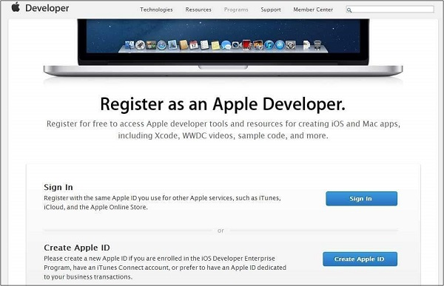
Step 2 − Provide the necessary information, which is self explanatory as given in the page.
Step 3 − Verify your account with your email verification and the account becomes active.
Step 4 − Now you will be able to download the developer tools like Xcode, which is packaged with iOS simulator and iOS SDK, and other developer resources.

Apple iOS Developer Program
The first question that would arise to a new developer is – Why should I register for an iOS developer program? The answer is quite simple; Apple always focuses on providing quality applications to its user. If there was no registration fee, there could be a possibility of junk apps being uploaded that could cause problems for the app review team of Apple.
The benefits of joining the iOS developer program are as follows −
- Run the apps you develop on the real iOS device.
- Distribute the apps to the app store.
- Get access to the developer previews.
The steps to join the iOS developer program are as follows −
Step 1 − To register, click on the link − (https://developer.apple.com/programs/ios/).
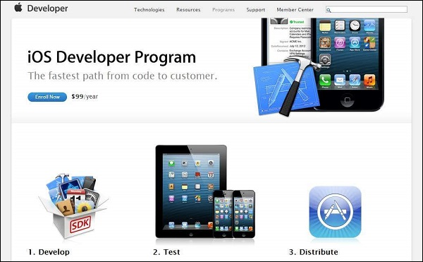

Step 2 − Click on Enroll Now in the page that is displayed.
Step 3 − You can either sign in to your existing apple account (if you have one) or create a new Apple ID.
Step 4 − Thereafter, you have to select between Individual and Company accounts. Use company account if there will be more than one developer in your team. In individual account, you can't add members.
Step 5 − After entering the personal information (for those who newly registers), you can purchase and activate the program by paying with the help of your credit card (only accepted mode of payment).
Step 6 − Now you will get access to developer resources by selecting the member center option in the page.
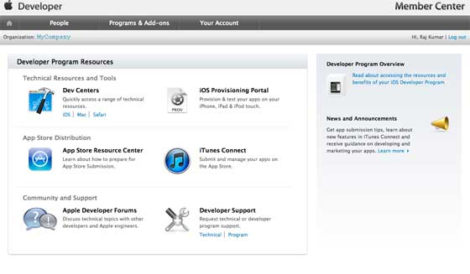
Step 7 − Here you will be able to do the following −
- Create provisioning profiles.
- Manage your team and devices.
- Managing application to app store through iTunes Connect.
- Get forum and technical support.

iOS Xcode Environment Setup
For development of iOS applications, we need to install Xcode editor, its apple integrated development environment (IDE). The Xcode editor is the primary development tool for any type of apple platforms like OSX Software’s, iPhones App, Mac, etc.

iOS Xcode Setup Requirements
The requirement of the Xcode editor is that we should have a minimum Apple Laptop or Mac Computer for development of the iOS applications. We can download Xcode editor from the Apple website or Apple app store and this editor is completely free we don’t need to pay anything for Apple.

Download Xcode from Apple Store
In case if you want to download Xcode from the Apple app store open the app store in the system and search for Xcode in the search bar and download it. Following is the screenshot which shows how to search Xcode and download from the app store.

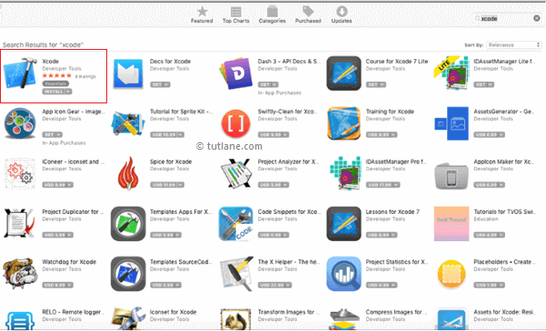

Download Xcode from Apple Website
In case if you want to download the Xcode from a website, we need to sign up for the Apple Developer Program which is free and download the Xcode editor but remember when we are going to publish our application Apple will charge 99$.

Once we sign up on the Apple website with the Apple account and go to the Downloads section and download the Xcode Editor. Use this Download Xcode Editor URL to login and download the Xcode editor.

If you open and login to the apple website by using the above URL go to the downloads section, you will find Xcode editor to download like as shown below

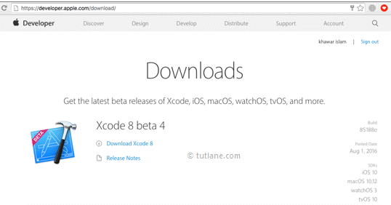

After download click on Xcode.dmg file just drag the Xcode and drop into
the Application folder like as shown below and our Xcode installation will take 2 to 3 minutes.

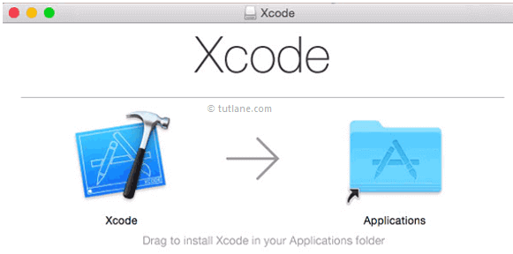

Interface Builder
Interface builder is the tool that enables easy creation of UI interface. You have a rich set of UI elements that is developed for use. You just have to drag and drop into your UI view. We'll learn about adding UI elements, creating outlets and actions for the UI elements in the upcoming pages.
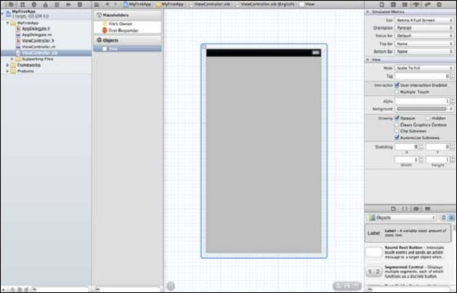
You have objects library at the right bottom that consists the entire necessary UI element. The user interface is often referred as xibs, which is its file extension. Each of the xibs is linked to a corresponding view controller.

iOS Simulator
An iOS simulator actually consists of two types of devices, namely iPhone and iPad with their different versions. iPhone versions include iPhone (normal), iPhone Retina, iPhone 5. iPad has iPad and iPad Retina. A screenshot of an iPhone simulator is displayed below.

You can simulate location in an iOS simulator for playing around with latitude and longitude effects of the app. You can also simulate memory warning and in-call status in the simulator. You can use the simulator for most purposes, however you cannot test device features like accelerometer. So, you might always need an iOS device to test all the scenarios of an application thoroughly.

iOS - Objective C

Objective-C is general-purpose language that is developed on top of C Programming language by adding features of Small Talk programming language making it an object-oriented language. It is primarily used in developing iOS and Mac OS X operating systems as well as its applications.
Initially, Objective-C was developed by NeXT for its NeXTSTEP OS from whom it was taken over by Apple for its iOS and Mac OS X.

Object-Oriented Programming
Objective-C fully supports object-oriented programming, including the four pillars of object-oriented development −
- Encapsulation
- Data hiding
- Inheritance
- Polymorphism

Foundation Framework
Foundation Framework provides large set of features and they are listed below.
- It includes a list of extended datatypes like NSArray, NSDictionary, NSSet and so on.
- It consists of a rich set of functions manipulating files, strings, etc.
- It provides features for URL handling, utilities like date formatting, data handling, error handling, etc.

Objective-C Example
A Objective-C program basically consists of the following parts −
- Preprocessor Commands
- Interface
- Implementation
- Method
- Variables
- Statements & Expressions
- Comments
In Object-Oriented Programming a Class represents the blue-prints of an object and its no different here. Generally, in objective-C code a class is represented in two files. A header file and an implementation file.
The header file is the interface for the class and it defines the properties and methods used in the class. The implementation file contains the code that brings these properties and methods into action.
The header file is used by other classes to interact with the current class. The implementation file is private to each class. The header file is defined under @interface and the implementation class is defined under @implementation.
- Interface
In Objective C, the file where the declaration of class is done is called the interface file. Every new class is declared with an @interface, followed by the custom class name, followed by a colon and ending with the name of the superclass.
For example, used NSObject as superclass. All classes are derived from NSObject since its the base class. It is the superclass of all Objective-C classes.
Everything between the @interface line and the @end line describes what is contained in the class.
A simple interface file MyClass.h would look like the following −
@interface MyClass:NSObject
{
// class variable declared here
}
// class properties declared here
// class methods and instance methods declared here
@end
- The instance variables of the class object are defined in curly braces. Instance variables store the individual characteristics of each object.
- The instance variables are private and are only accessible inside the class implementation.
- Instance Methods are declared just above @end.
- Properties are used to provide access to class instance variables in other classes.

Properties
Properties are used to provide access to class instance variables in other classes.
Declaring a property always starts with @property followed by property attributes. Following are some important attributes :
- assign : It’s used to assign a new value to the property anytime
- nonatomic : Thread access is faster. But we cannot simultaneously access and change the value
- readonly : We cannot directly assign new values to these properties
- copy : The value assigned to the property can be copied and used for other purposes
- readwrite : We can read and change the value of a property
- strong : We have direct control over the lifetime of the property
- weak : We can nullify the property and so can the compiler

Methods
Method declarations begin with either a minus (-) or a plus sign (+).
- The minus sign indicates that this method is an instance method.
- This means that an object of the class must be created and initialised to call this method.
- The plus sign indicates that this method is an class method.
- It can be used simply by referencing the class. No instance of the class is needed.

Object Instance Method Declaration.
The minus sign begin method is an object method. The method’s return and argument parameter type must be enclosed in parentheses. The formal parameters of the function are denoted by a colon.
Syntax: – (return value type) method name: (parameter type) parameter name.
Method is declared in Objective C as follows −
-(returnType)methodName:(typeName) variable1 :(typeName)variable2;

@interface Employee : NSObject
// Below is a instance method declaration, it has three argument, userName, password and email.
- (Void) regist:(NSString * )userName setPassword:(NSString * ) password setEmail:(NSString *) email;
@end
Instance methods can be accessed only after creating an object for the class. Memory is allocated to the instance variables. An example instance method is shown below.
-(void)simpleInstanceMethod;
It can be accessed after creating an object for the class as follows −
MyClass *objectName = [[MyClass alloc]init] ;
[objectName simpleInstanceMethod];

Class Method Declaration.
The plus sign represents the static method (class method).
Syntax: + (return value type) method name: (parameter type) parameter name.
@interface Employee : NSObject
+(Void) login:(NSString * )userName setPassword:(NSString * ) password;
@end

Class methods can be accessed directly without creating objects for the class. They don't have any variables and objects associated with it. An example is shown below.
+(void)simpleClassMethod;
It can be accessed by using the class name (let's assume the class name as MyClass) as follows −
[MyClass simpleClassMethod];

Different Between Object Method And Class Method.
Object methods can access properties directly, while class methods can not. Class methods can be invoked directly with class name, but object methods can not.

3. Implementation
The file where the class is defined is called the implementation file.

The implementation file MyClass.m would be as follows −
@implementation MyClass
// class methods defined here
@end

4. Create A New Instance.
There are two methods for you to create an Objective-C object, new and alloc, init. The difference between them are:
- The new method can only use default init method to initialize the object.
- But the alloc method can use a custom initialize method.

Use new Method.
Inside the new method, alloc and init are called separately in order.
- alloc method is used to allocate storage space and returns the assigned object.
- init method is used to initialize the returned object.

Employee *employee=[Employee new];

Use alloc and init Method Manually.
alloc is a class method and init is a object method. alloc method just return an object of the class, init method will initialize all the object properties value to 0 by default.
Object creation is done as follows −
MyClass *objectName = [[MyClass alloc]init] ;

Example
Employee *employee=[[Employee alloc] init];
Please Note : After the default initialization is complete, all member variables value will be initialized to 0. When you do not want to use an object you should release it’s related memory with below code.
[employee release];

5. Access Object Property.
syntax: object -> property name
employee->userName;
employee->password;
(*employee).userName;

6. Call Object Methods.
To call a method on an Objective-C object, we need to place the instance and the method in square brackets, separated by a space. Arguments(if any) are passed after the method name, preceded by a colon.

Call No Argument Method.
Syntax :[object name method name]

[employee work]

Call Method With Arguments.
Syntax :[object name method name: parameter]

[employee register:@"Tom" password:@"888888" email:@"tom@gmail.com"]

Hello world Example
Let us look at a simple code that would print the words "Hello World" −
#import <Foundation/Foundation.h>

@interface SampleClass:NSObject
- (void)sampleMethod;
@end

@implementation SampleClass

- (void)sampleMethod
{
NSLog(@"Hello, World! \n");
}

@end

int main() {
/* my first program in Objective-C */
SampleClass *sampleClass = [[SampleClass alloc]init];
[sampleClass sampleMethod];
return 0;
}
Let us look various parts of the above program −
- The first line of the program #import <Foundation/Foundation.h> is a preprocessor command, which tells a Objective-C compiler to include Foundation.h file before going to actual compilation.
- The next line @interface SampleClass:NSObject shows how to create an interface. It inherits NSObject, which is the base class of all objects.
- The next line - (void)sampleMethod; shows how to declare a method.
- The next line @end marks the end of an interface.
- The next line @implementation SampleClass shows how to implement the interface SampleClass.
- The next line - (void)sampleMethod{} shows the implementation of the sampleMethod.
- The next line @end marks the end of an implementation.
- The next line int main() is the main function where program execution begins.
- The next line /*...*/ will be ignored by the compiler and it has been put to add additional comments in the program. So such lines are called comments in the program.
- The next line NSLog(...) is another function available in Objective-C which causes the message "Hello, World!" to be displayed on the screen.
- The next line return 0; terminates main()function and returns the value 0.

Objective-C Data Types
In the Objective-C programming language, data types refer to an extensive system used for declaring variables or functions of different types. The type of a variable determines how much space it occupies in storage and how the bit pattern stored is interpreted.
The types in Objective-C can be classified as follows −
Sr.No. | Types & Description
1 | Basic Types −  They are arithmetic types and consist of the two types: (a) integer types and (b) floating-point types.
2 | Enumerated types −  They are again arithmetic types and they are used to define variables that can only be assigned certain discrete integer values throughout the program.
3 | The type void −  The type specifier void indicates that no value is available.
4 | Derived types −  They include (a) Pointer types, (b) Array types, (c) Structure types, (d) Union types and (e) Function types.
The array types and structure types are referred to collectively as the aggregate types. The type of a function specifies the type of the function's return value. We will see basic types in the following section whereas other types will be covered in the upcoming chapters.

Integer Types
Following table gives you details about standard integer types with its storage sizes and value ranges −
Type | Storage size | Value range
char | 1 byte | -128 to 127 or 0 to 255
unsigned char | 1 byte | 0 to 255
signed char | 1 byte | -128 to 127
int | 2 or 4 bytes | -32,768 to 32,767 or -2,147,483,648 to 2,147,483,647
unsigned int | 2 or 4 bytes | 0 to 65,535 or 0 to 4,294,967,295
short | 2 bytes | -32,768 to 32,767
unsigned short | 2 bytes | 0 to 65,535
long | 4 bytes | -2,147,483,648 to 2,147,483,647
unsigned long | 4 bytes | 0 to 4,294,967,295
To get the exact size of a type or a variable on a particular platform, you can use the sizeof operator. The expression sizeof(type) yields the storage size of the object or type in bytes. Following is an example to get the size of int type on any machine –

#import <Foundation/Foundation.h>

int main() {
NSLog(@"Storage size for int : %d \n", sizeof(int));
return 0;
}
When you compile and execute the above program, it produces the following result on Linux −
2013-09-07 22:21:39.155 demo[1340] Storage size for int : 4

Floating-Point Types
Following table gives you details about standard float-point types with storage sizes and value ranges and their precision −
Type | Storage size | Value range | Precision
float | 4 byte | 1.2E-38 to 3.4E+38 | 6 decimal places
double | 8 byte | 2.3E-308 to 1.7E+308 | 15 decimal places
long double | 10 byte | 3.4E-4932 to 1.1E+4932 | 19 decimal places
The header file float.h defines macros that allow you to use these values and other details about the binary representation of real numbers in your programs. Following example will print storage space taken by a float type and its range values −
#import <Foundation/Foundation.h>

int main() {
NSLog(@"Storage size for float : %d \n", sizeof(float));
return 0;
}
When you compile and execute the above program, it produces the following result on Linux −
2013-09-07 22:22:21.729 demo[3927] Storage size for float : 4

Sr.No. | Data Type
1 | NSString  It is used for representing a string.
2 | CGfloat  It is used for representing a floating point value (normal float is also allowed but it's better to use CGfloat).
3 | NSInteger  It is used for representing integer.
4 | BOOL  It is used for representing Boolean (YES or NO are BOOL types allowed).

Printing Logs
NSLog - used for printing a statement. It will be printed in the device logs and debug console in release and debug modes respectively. For example,
NSlog(@"");

1. int holds number value without decimal
int quantity = 10;
NSInteger quantity=10;
Here int = Datatype , quantity = Variable ,10 = Variable value
NSLog(@”quantity = %d”,quantity); //use NSLog with %d to print int value
Output : quantity = 10
2. float holds number value with decimal
float pi = 3.14;
CGFloat pi=3.14;
Here float = Datatype , pi = Variable ,10 = Variable value
NSLog(@”Value of pi = %f”,pi); // use NSLog with %f to print float value
Output : Value of pi = 3.14
3. Char holds single character value
char a = ‘A’;
NSString a=’A’
Here char = Datatype , a = Variable , A = Variable value
NSLog(@” Value of a = %c”,a); //use NSLog with %c to print float value
Output : Value of a = A
4. String holds single character as well text.
NSString *strName = @”Verma Mukesh”;
Here String = Datatype , strName = Variable , Verma Mukesh = Variable value
NSLog(@”My name is = %@“,strName); //use NSLog with %@ to print string value
Output : My name is = Verma Mukesh
5. BOOL represent TRUE or FALSE.
BOOL areYouGreatLearner = YES;
Here BOOL = Datatype , areYouGreatLearner = Variable , YES = Variable value
NSLog(@“Value of areYouGreatLearner is %d“, areYouGreatLearner); //use NSLog with %d to print BOOL value, it will print 1 for true and 0 for false

